**Amy Wang**

**MSCI 240 Fall 2018**

**Instructor: Dr Mark Hancock**

**November 17th, 2018**

**Project 2**

**Introduction:**

The goal of this project is to use 3 types of maps to add players and their count of plays based on a hockey data list. The maps being tested are an ArrayList, TreeSet, and a HashMap, all of type PlayCount object. The PlayCount object will have a String field for name of player and an Integer field for Count of plays. The maps must have unique players with their count numbers with the task’s algorithm being to add a new player if the player is not in the map’s roster or find the player and increase the count for number of plays. After implementing the maps, we must use a timer to collect data on how efficient each map is for this task and compare complexities. Additionally, after all the data is interpreted and stored, a PriorityQueue will allow for the output of the players with the top 20 amounts of plays. At the end of the report it can clearly be proven which map is the best option to complete tasks of this nature.

**Map Implementations:**

1. **ArrayList:**
2. **TreeSet:**
3. **HashMap:**

Unique & Top 20 Players:

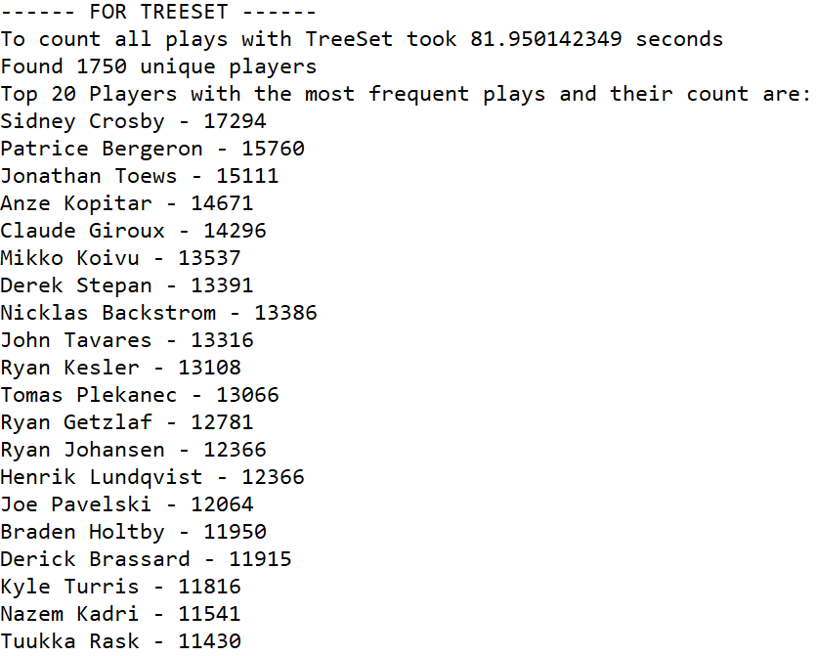

**Discussions:**

**Performance**

**Top 20 Players**

**Issues**

**Data Collected & Output:**

**Trial 1:**

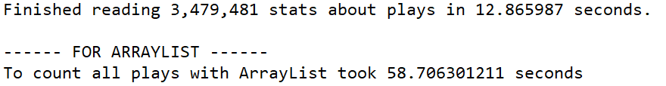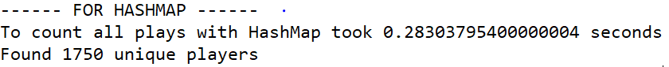

# **Trial 2:**

# **Trial 2:**

# 

# 

**Tabulated Results:**

|  |  |  |  |
| --- | --- | --- | --- |
| Element | Trial 1 (s) | Trial 2 (s) | Average |
| Read | 12.865987 | 13.304032 | 13.085 |
| ArrayList | 58.706301 | 54.620364 | 56.663 |
| TreeSet | 81.816561 | 81.950142 | 81.883 |
| HashMap | 0.2830380 | 0.2787884 | 28.091 |

Figure 12.2 Mapping time data

**Code from Eclipse IDE:**

**PlayCount.Java:**

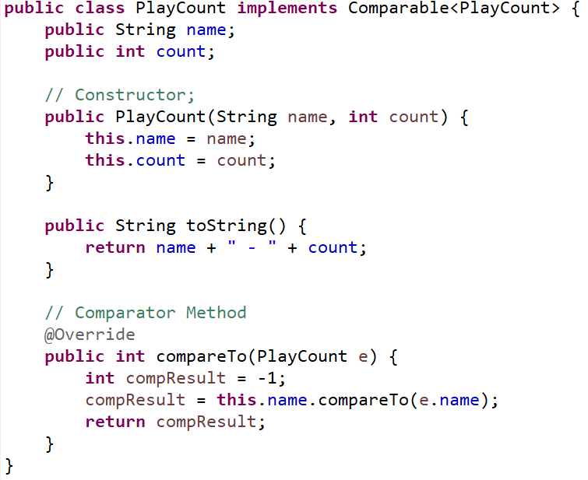

Figure

**Program.Java:**

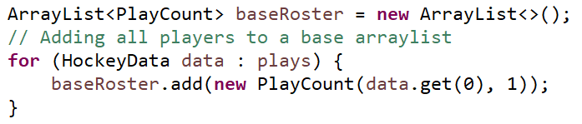

Figure

*Comparator Methods (Treeset & ArrayList, HashMap):*

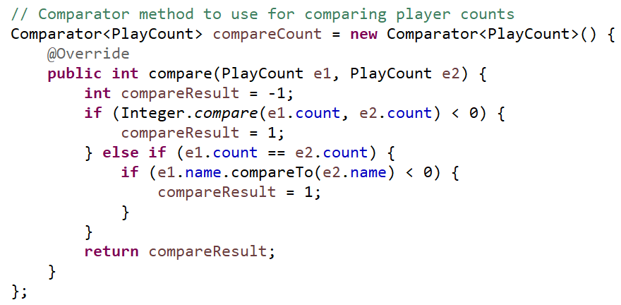

Figure

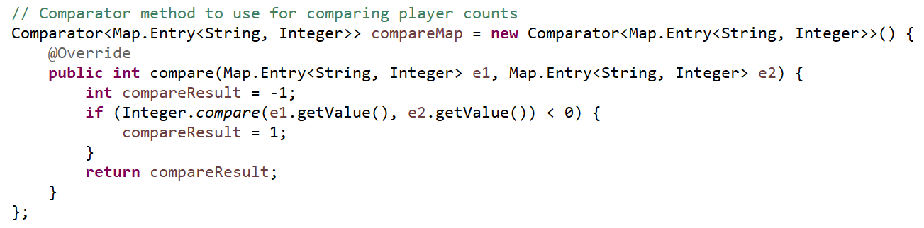

Figure

*Implementing ArrayList Map:*

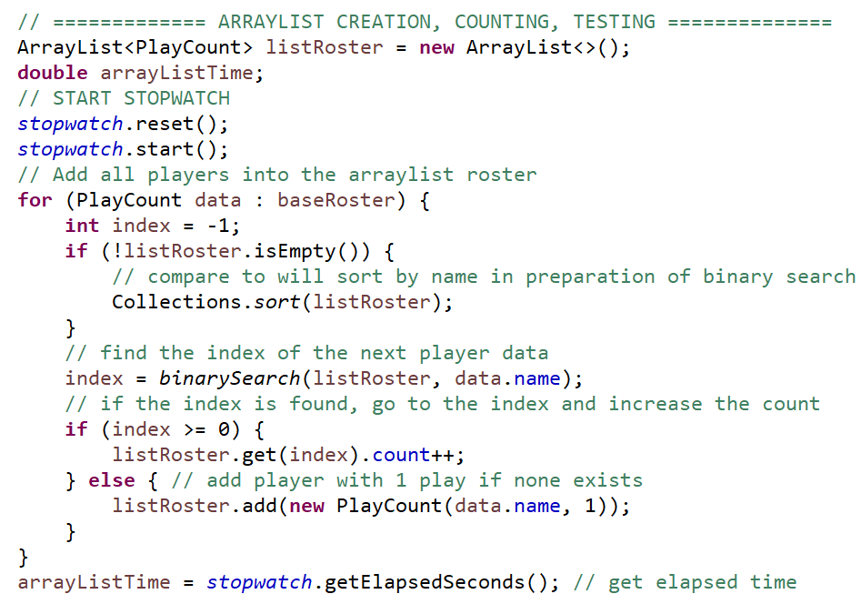

Figure

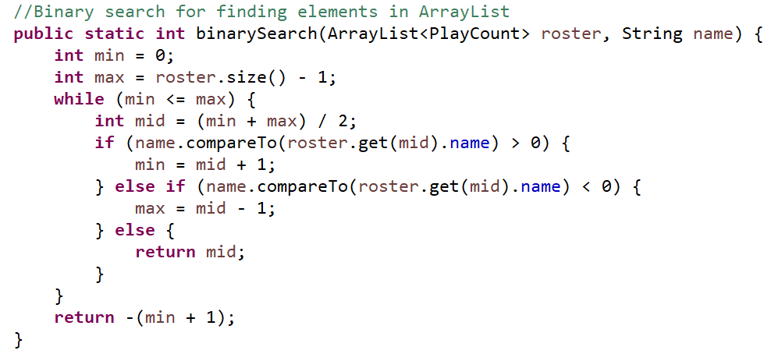

Figure

*Implementing TreeSet Map:*

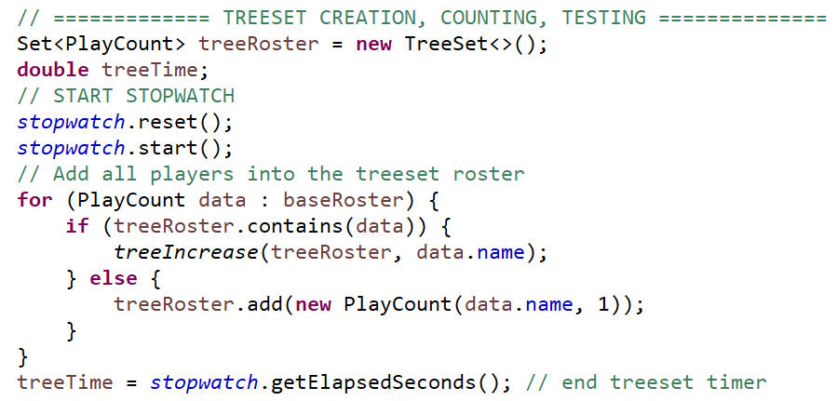

Figure

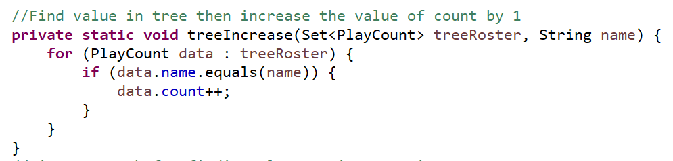

Figure

*Implementing HashMap Map:*

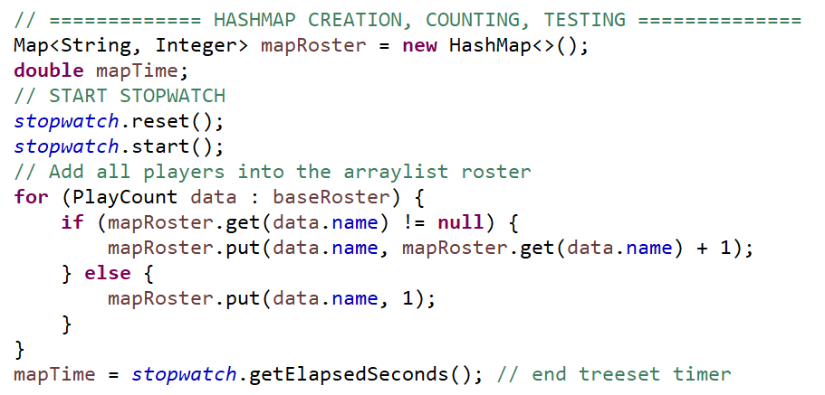

Figure

*Implementing Priority Queues:*

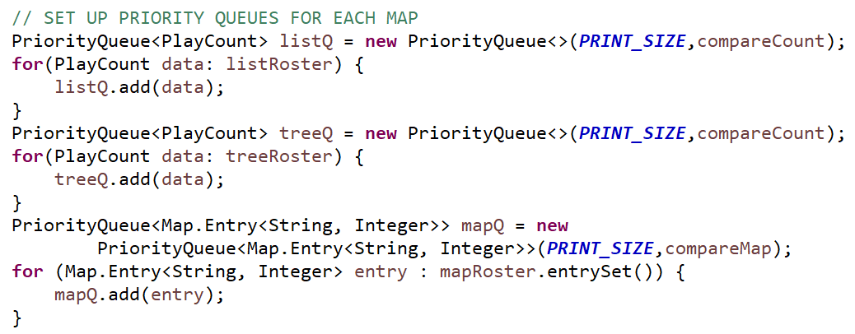

Figure

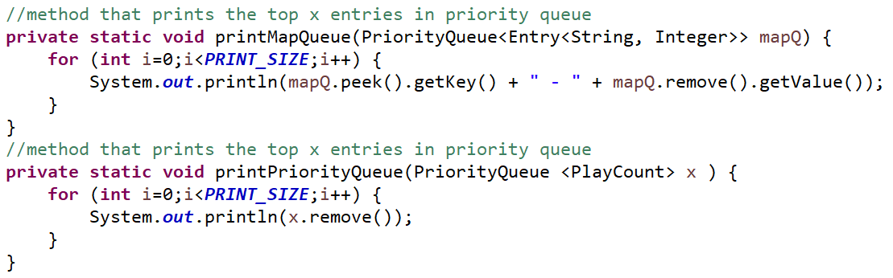

Figure

*Printing required information:*

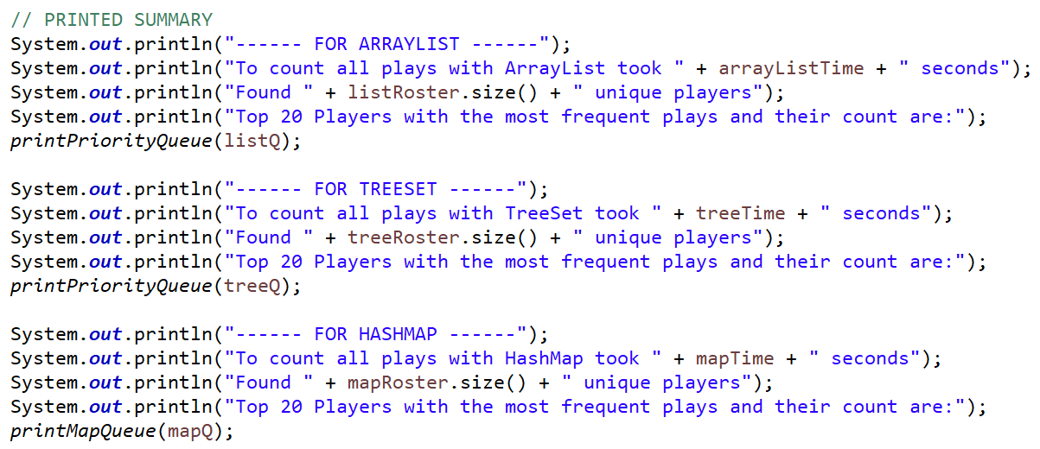

Figure

# Non-Acknowledgment of Receiving Assistance or Use of Others' Ideas

I received the following help, assistance, or any ideas from classmates, other knowledgeable people, books or non-course websites (please include a description of discussions with the TA or the instructor):

None

# Record of Giving Assistance to Others

I gave the following help, assistance, or ideas to the following classmates (please describe what assistance to whom was given by you):

None

# Declaration

I declare that except for the assistance noted above, assistance provided on the course website, and material provided by the instructor and/or TAs that this is my original work.

I have neither given nor received an electronic or printed version of any part of this code to/from anyone.

I declare that any program output submitted as part of the assignment was generated by the program code submitted and not altered in any way.



Signature: _______________________________